Operating Systems Lab
Lab Task # 01
Name: Syeda Memona Zahra
Roll No: F2024332054

Q1. Create a folder with your name and roll number
Commands:
mkdir Memona-F2024332054
ls
Output:
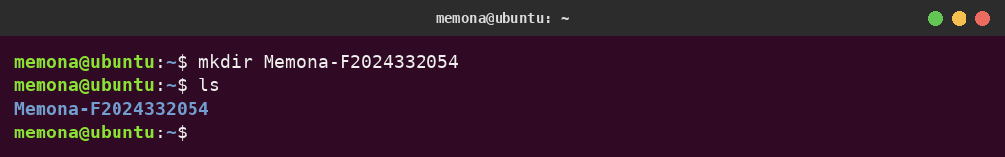
Description:
A new directory called Memona-F2024332054 is made in the home folder using mkdir. Running ls afterwards lists what is in the home folder, and the new directory appears in blue, which confirms it was created successfully.

Q2. Create 5 nested sub-folders (folder 01 to folder 05)
Commands:
cd Memona-F2024332054
mkdir -p folder01/folder02/folder03/folder04/folder05
ls
Output:
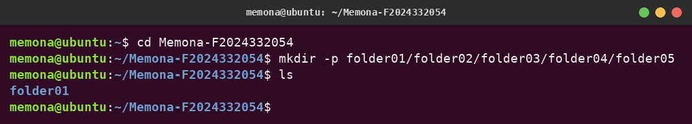
Description:
First, cd is used to enter the Memona-F2024332054 directory. Then mkdir -p builds the complete chain of folders in a single step, placing each folder inside the previous one (folder01 holds folder02, folder02 holds folder03, and so on until folder05). The -p flag automatically creates any parent folders that do not exist yet. ls shows folder01 at the top level.

Q3. Display the folder structure recursively
Commands:
cd ~
ls -R Memona-F2024332054
Output:
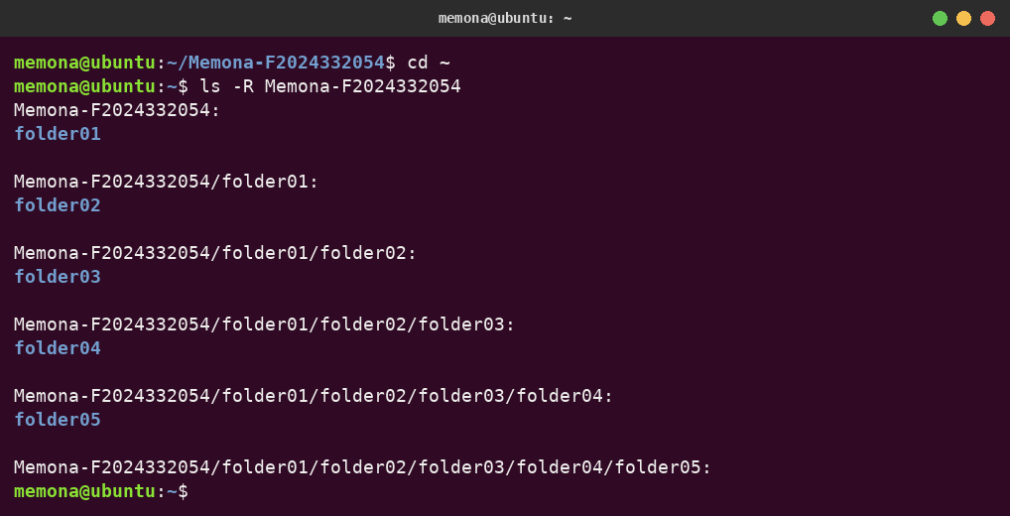
Description:
After returning to the home directory with cd ~, the command ls -R prints the contents of Memona-F2024332054 and then goes into every sub-directory one after another. Each block in the output starts with a folder path, so it clearly shows the five folders nested one inside the other.

Q4. Create a file in folder 03 with nano and write a 2-line intro
Commands:
cd Memona-F2024332054/folder01/folder02/folder03
nano about_me.txt
ls -l
Intro typed inside nano:
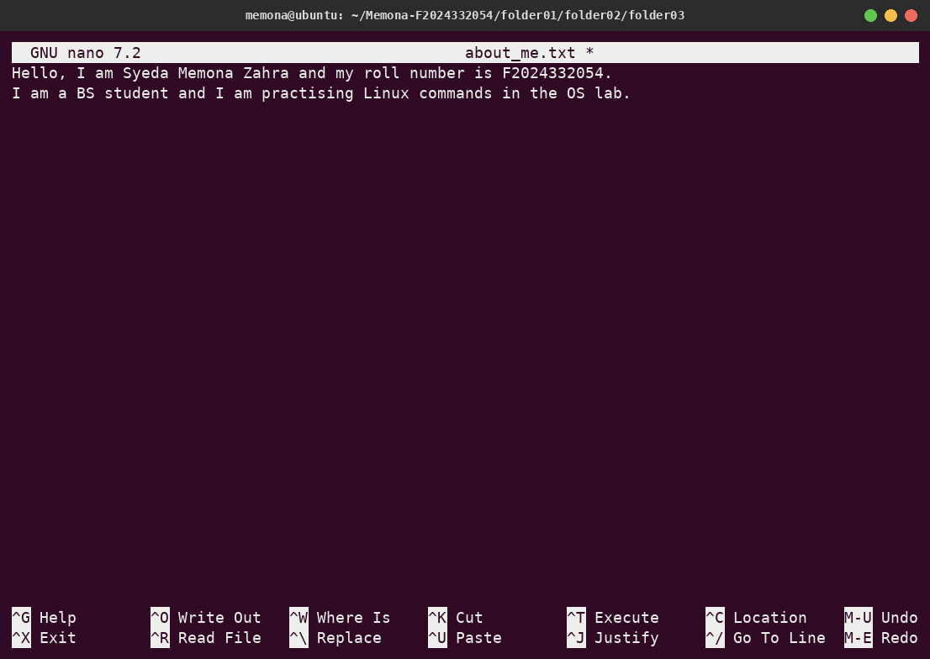
Checking the saved file:
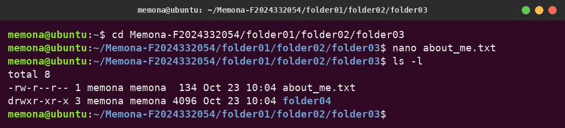
Description:
The cd command takes us to folder03. Running nano about_me.txt opens the nano editor and creates a new file called about_me.txt. A two-line introduction was entered, saved with Ctrl + O followed by Enter, and the editor was closed using Ctrl + X. Finally, ls -l gives a detailed listing that confirms about_me.txt (134 bytes) is now stored in folder03 along with folder04.

Q5. Show the saved file content on the console
Command:
cat about_me.txt
Output:
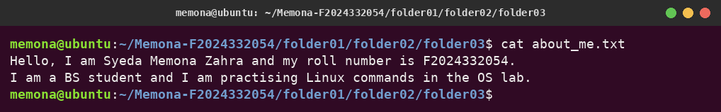
Description:
The cat command reads the about_me.txt file and outputs its text straight to the terminal. Both lines of the introduction written in nano are shown on the screen.

